# Lab 7: Working with Relational Databases

While our initial investigations have dealt with Hive and SparkSQL, often as a Data Scientist, you will encounter relational databases like PostgreSQL. In this lab, you’ll explore the basics of loading data into Postgres, creating running queries and understanding how those queries are transformed into plans for DAGs. Submit your answers through the LMS as a text file, docx file, or PDF.

## Getting the Data

Navigate to the /data directory on your AWS instance or the $HOME directory on your Vagrant install. Download the Pagila data as follows:

wget -O pagila.zip <http://pgfoundry.org/frs/download.php/1719/pagila-0.10.1.zip>

unzip pagila.zip

Next, we’re going to log into postgresql and import the data.

Log into postgres as the postgres user:

psql –U postgres

Now create the database:

create database dvdrental;

Connect to the database using \c

\c dvdrental

Load the data using the \i command. \i runs .sql scripts in Postgres.

\i pagila-0.10.1/pagila-schema.sql

\i pagila-0.10.1/pagila-insert-data.sql

\i pagila-data.sql

At this point the data is loaded. Examine the database schema using the \dt command. Examine the schema of a table using the \d <table name> command

### Question 1: What is the output of \dt?

### 

### Question 2: What is the schema for the customer table?

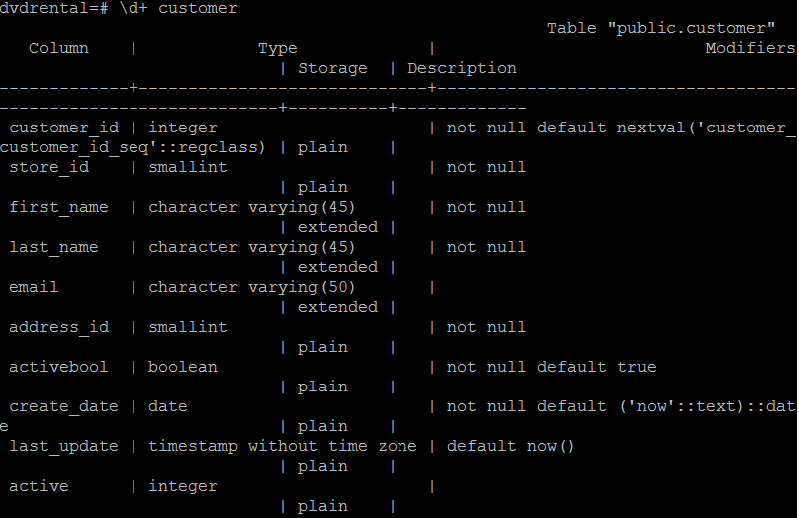

## Running Queries and Understanding EXPLAIN plans

We want to understand not only what queries we can issue against data, but also how that query maps to an execution plan. For each of the following sections, run the queries provided, and generate their explain plans using: EXPLAIN <sql query here>

### Projection and Selection

Run the following simple queries, then generate their explain plans.

Projection

SELECT customer_id, first_name, last_name FROM customer;

Projection and Selection #1

SELECT customer_id,

amount,

payment_date

FROM payment

WHERE amount <= 1 OR amount >= 8;

Projection and Selection #2

SELECT

customer_id,

payment_id,

amount

FROM

payment

WHERE

amount BETWEEN 5

AND 9;

### Question 3: What similarities do you see in the explain plains for these 3 queries?

All 3 involve at least one sequential scan on a table

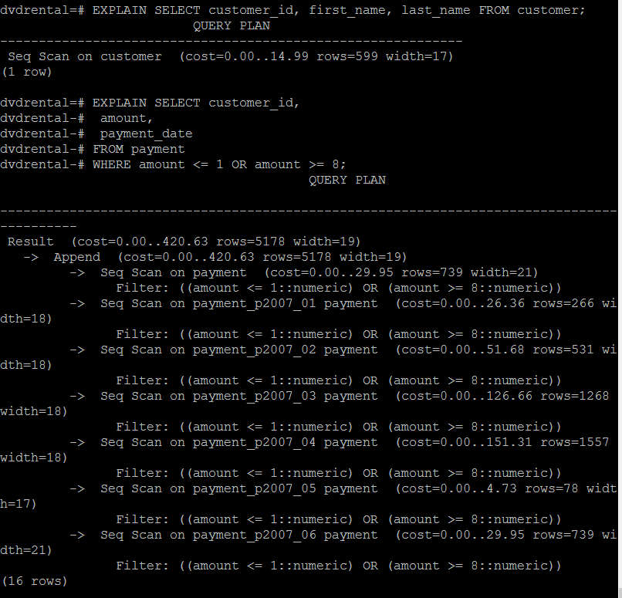

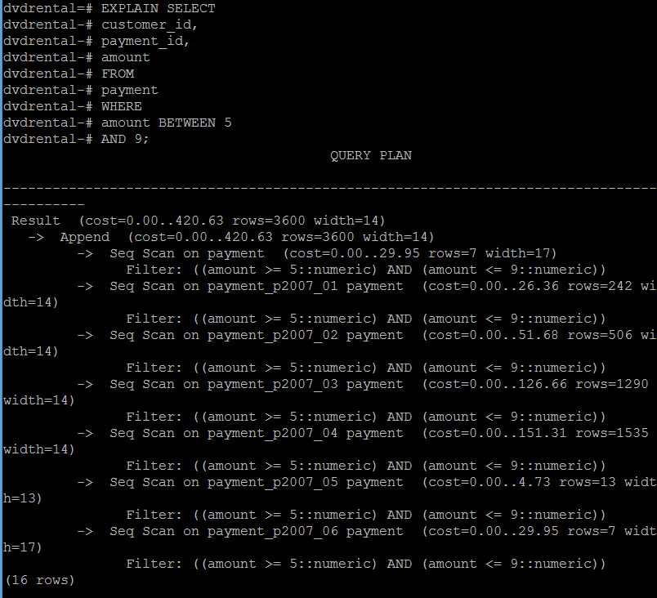

### Merging Data: JOINs and UNIONs

Run the following statements:

Union 2 tables:

SELECT u.customer_id, sum(u.amount) from (

SELECT *

FROM

payment_p2007_01

UNION

SELECT *

FROM

payment_p2007_02

) u

WHERE u.payment_date <= '2007-02-01 00:00:00'::timestamp without time zone

GROUP BY u.customer_id

;

Partitioned Table

SELECT customer_id, sum(amount) from

payment

WHERE payment_date <= '2007-02-01 00:00:00'::timestamp without time zone

GROUP BY customer_id

;

### Question 4: What is the difference between the plans for the Partitioned table and the union query? Why do you think this difference exists?

The only difference that I can think of is that the partitioned table has three sequential scans as opposed to two, and my guess is because payment is made of sub-tables and the meta-table refers to the sub-tables which are then accessed, and the efficiency gain from the partitioning isn’t there because partition is set on payment_id as opposed to payment_date so we still have to scan both payment sub-tables entirely as opposed knowing that we can ignore feb.

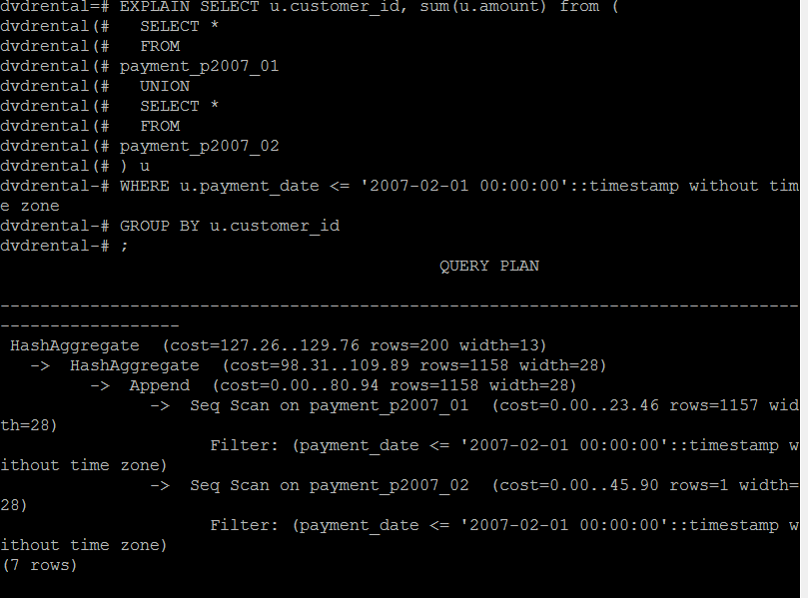 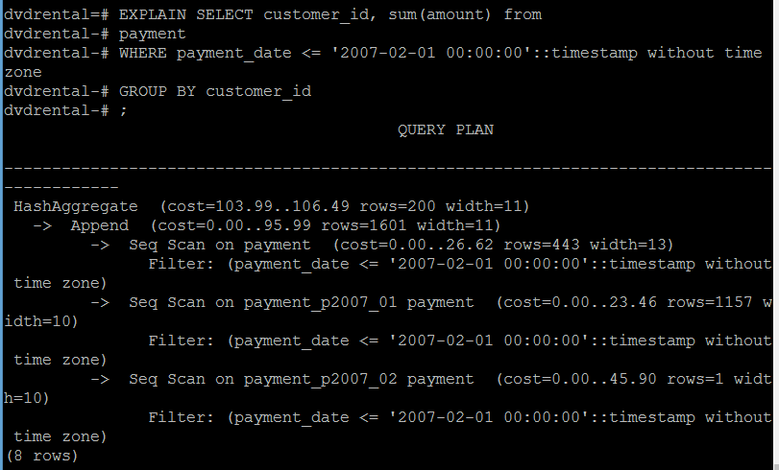

Join 2 tables

SELECT

customer.customer_id,

first_name,

last_name,

email,

amount,

payment_date

FROM

customer

INNER JOIN payment ON payment.customer_id = customer.customer_id;

### Question 5: What join algorithm is used for the inner join?

Hash join?

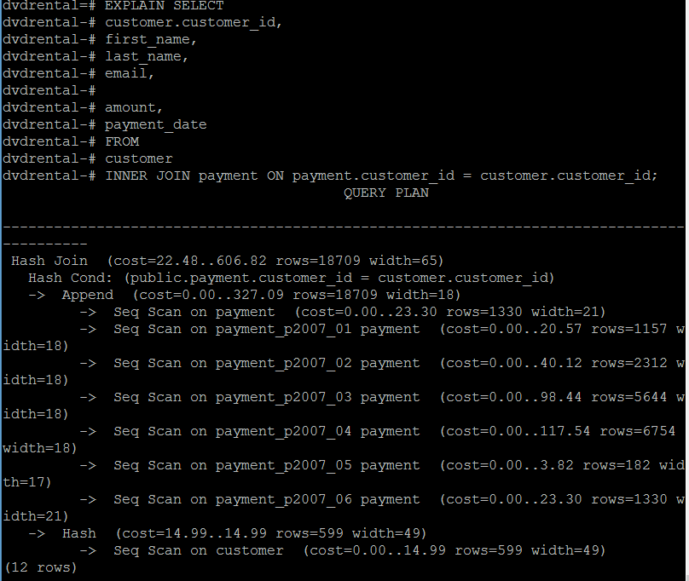

Finally, disconnect from postgres, using \q